

**Product Dissection for X (Formerly Twitter)**

**Company Overview:**

Twitter,rebranding itself as X in 2023,is an online social media and social networking platform launched in July 2006 by Jack Dorsey,Noah Glass,Biz Stone,and Evan Williams. It is owned by an American company X Corp.,the successor of Twitter,Inc. With time X transformed the way people interact with each other through posting text , images and videos. Acquired by American billionaire Elon Musk in 2022 it has become a major platform for influencers,news media,content creators and many others to interact with general public. X has currently 528 million monthly active users which is estimated to reach 620 million by 2028 .

### **Product Dissection and Real-World Problems Solved by X:**

Since its inception X provided a vital service of interconnecting millions across the globe through communication in visual and textual format. People can post short messages and videos as well as photos to a larger audience. These posts can be embedded with locations,hashtags, and captions for photos and videos. Longer text and video posts as well as other additional features can be accessed if the user has subscribed to X premium. Other people can like,comment or repost these posts if they find it interesting or useful for them. We can follow any individual or organization and see their posts on our home page. It also has a service named ‘Spaces’ for live audio conversations where many people can come together,talk and listen to each other. We can also join and create communities of like minded individuals to share,discuss and gain knowledge on subjects of common interests. In short X provided a way to digitally minimize distances between people around the world.

Now we will analyze the real world problems solved by X:

#### **Problem 1: Disconnect Between People**

**Real-World Challenge:** Ever increasing number of people coming online makes it mandatory to establish efficient digital connection between them.

**X Solution:** People can write posts,share videos and photos for the general public. Other people can see their content and follow them if they find their posts useful. They can also like, comment and repost their posts. These facilities ensure a proper digital relationship between users of X. They can interact,share and learn from each other which can positively impact their personal and professional lives.

#### **Problem 2: Dearth of Platforms to Showcase Talent**

**Real-World Challenge:** Many people have special talent and expertise in their respective fields but they struggled to find a platform to showcase them to the general public.

**X Solution:** People with expertise in different fields like sports, arts, humanities etc. can gain a wider audience for their talents on X. They can write posts related to their field of interest and can also visually communicate and explain their thoughts through photos and videos. This will help the individual or organization to gain publicity which can positively impact their professional lives

#### **Problem 3: Limited Ways to Broadcast Information**

**Real-World Challenge:** Broadcasting information and reaching people in a limited time had been difficult through conventional mediums like television and radio.

**X Solution:** Individuals, organizations, governments, news media etc. can easily broadcast information related to traffic,weather,government advisories,crime and others in real time especially through app based smartphones. This comes handy when we have limited time to make information reach to general public

#### **Problem 4: Limited Platforms to Gain Knowledge and Awareness**

**Real-World Challenge:** Internet might be a great source to gain knowledge and awareness but still there is an issue of learning directly from experts and gain real time updates about the outside world

**X Solution:** X provides the platform for users to follow and ask questions directly to the experts of their field of interest to gain knowledge. Most discussed topics can be looked at through hashtags in the trending section. It also helps in getting real time updates of events outside by following individuals or organizations providing the same. For example by following the X handle of meteorological department we can get real time updates about the weather of our city

#### **Problem 5: Extra Means to Generate Income**

**Real-World Challenge:** There were low opportunities for converting knowledge into wealth and gaining extra income before the advent of social media.

**X Solution:** X provides for getting paid subscriptions from followers who want to learn and interact with you. Public funding for your work can also be done by providing payment links through your posts and requesting general public to donate

#### **Conclusion:**

X provided a way to transform and positively change our personal and professional lives by connecting with the outside world. We can gain knowledge,interact with experts,generate income and become an individual with great awareness. In short, X is a way of changing the world for the good.

### **Case Study: Real-World Problems and X's Innovative Solutions**

Arun is a fitness enthusiast. He regularly exercises,play sports and eats only nutritious food. Despite doing all these endeavors he was not satisfied with his physical health. He thought his weight was still on a higher side and stamina was not up to the mark. He wanted expert guidance for himself. He tried searching the internet but found so much material,which was often conflicting,that he became more confused about his health than before. He became depressed after not finding a perfect solution for his problem. Then one day his friend recommended him to follow a well known fitness trainer Raghav on X. He accepted his advice and started following Raghav. Raghav regularly posts health advice on X. He recommends how to exercise,what to eat in what quantity and special fitness advice according to a person’s age and health. Arun found his content interesting. He followed his recommendations according to his needs and started feeling positive changes in his health. Still he felt there is something missing in his health routine. To get answers to his questions he regularly commented on his posts and sent direct messages to him but there was no reply for some time. But one day Raghav replied to him and seeing the opportunity Arun requested a personal conversation to which Raghav agreed. Arun highlighted his problems which Raghav noted down. After sometime Raghav prepared a health routine for him which included different exercises and dietary recommendations. Arun thanked him and followed his advice religiously. After 6 months of intense discipline with the routine he felt he had achieved his health objectives. His weight reduced,his stamina increased and he became more confident about himself. Now he wanted others to also benefit from his learnings of the past many months. He started giving health advice from his X account. In no time he gathered hundreds of followers. To gain extra income he also started paid subscriptions for people who wanted personalized health recommendations. Now Arun is a fit man with an additional income source all thanks to X.

This case study is a perfect example of how X can be leveraged to one’s advantage not just for personal benefit but for professional benefit as well. This is just one of the ways by which people can revolutionize their life through effective use of X

### **Top Features of X:**

1. **User Profile -** In profile we give our full name, username which acts as our unique identity on X, profile picture and bio which tells other users about us like our profession, interests etc.
2. **Posts -** We can post short texts (long text if we subscribed to X premium) , short videos (long video if we subscribed to X premium) , photos and can also go live for other users. We can also tag our location, and caption our videos and photos
3. **Like -** We can like other users' posts if we find them interesting or useful to show our appreciation.
4. **Comment -** We can comment on other post if we want to convey something about it to the creator of the post or to viewers of the post
5. **Follower and Following -** We can follow other users who we admire or want to see their posts regularly. It is a major feature to increase our connections and evaluate our reach on X by the number of our followers
6. **Direct Message -** We can send a personal message to a user on X without publicizing it to other users
7. **Hashtags -** Through this feature we can search what other people are talking about a particular topic and also share our views. Ex - if we want to search content related to a match between India and Australia then we can use hashtag #INDVSAUS.
8. **Share -** We can share the content of X to other apps like facebook,whatsapp etc.
9. **News -** We can search news about different subjects like sports,entertainment etc. through the different news sections created in X.
10. **Spaces -** Space is a live audio communication feature in which many people can come together and share their views on a particular subject.
11. **Communities -** It is a group of like minded individuals having same interest who share their views, works, projects, suggestions etc. for the benefit of other members of the community

### 

### **Schema Description:**

Schema for X represents different entities that cover major aspects of the platform. Entities include users,likes,comments,followers,spaces etc. Each entity has multiple attributes which describes its functionality as well as its relationship with other entities

**User Entity:**

It provides information about each user of the platform:

* **User_Id (Primary Key) -** Provides a unique identity to each user
* **Username -** Username for each account
* **Full_Name -** Name of the user
* **Bio -** Description of the user
* **Location -** Location of the user
* **Date_of_Birth -** Birth date of the user
* **Date_of_Joining -** Date of joining X

**Post Entity:**

It provides information about the posts of users:

* **Post_Id (Primary Key) -** Unique identity of each post
* **User_id (Foreign Key Referencing User Entity) -** User who created the post
* **Caption -** Text of the post
* **URL -** URL of the image or video of the post
* **Time -** Time of the post
* **Date -** Date of the post
* **Views -** Number of views of the post

**Like Entity:**

Provides information about the likes by users:

* **Like_Id (Primary Key) -** Unique identifier of each like
* **User_Id (Foreign Key referencing User Entity)** - User who liked the post
* **Post_Id (Foreign Key referencing Post Entity)** - Post on which user liked
* **Time** - Time when user liked
* **Date** - Date when user liked

**Comment Entity:**

Provides information about the comments on the post:

* **Comment_Id (Primary Key)** - Unique identifier for each comment
* **User_Id (Foreign Key referencing User Entity) -** User who commented on the post
* **Post_Id (Foreign Key referencing Post Entity) -** Post on which user commented
* **Time** - Time when user commented
* **Date** - Date when user commented

**Follower Entity:**

Provides information about the relationship between users:

* **Follower_Id (Primary Key)** - Unique identifier for each relationship
* **User_Id_Follower (Foreign Key referencing User Entity) -** User who follow other account
* **User_Id_Following (Foreign Key referencing User Entity) -** Account which user is following
* **Follow_Date -** Date when relationship started

**Hashtag Entity:**

Provides information about the hashtags:

* **Hashtag_Id (Primary Key)** - Unique identifier for each hashtag
* **Tag -** Tag of the hashtag

**PostHashtag Entity:**

Provides information about the posts associated with hashtags:

* **PostHashtag_Id (Primary Key)** - Unique identifier for each posthashtag
* **User_Id (Foreign Key referencing User Entity) -** User who created post with hashtag
* **Hashtag_Id (Foreign Key referencing Hashtag Entity) -** Hashtag of the post
* **Post_Id** **(Foreign Key referencing Post Entity) -** Post with the hashtag

**Direct Message Entity:**

Provide information about personal messages exchanged between users

* **Direct_Message_Id (Primary Key)** - Unique identifier for each direct message
* **User_Id_Sender (Foreign Key referencing User Entity) -** User who sent the message
* **User_Id_Receiver (Foreign Key referencing User Entity) -** User who received the message

**Space Entity:**

Provide information about the live audio conversation feature Spaces

* **Space_Id (Primary Key)** - Unique identifier for each Space created
* **User_Id (Foreign Key referencing User Entity) -** User who created the space

**Community Entity:**

Provide information about communities

* **Community_Id (Primary Key)** - Unique identifier for each community
* **User_Id (Foreign Key referencing User Entity) -** User who created the community

**Relationships are:**

* **Users post posts -** Users posts on X
* **Users like posts -** Users can like posts of other users as well as their own posts
* **Users comments on posts -** Users can comment on posts of other users as well as their own posts
* **Users follows other users -** Users can follow other users as well as be followed by others
* **Users posts with hashtag -** Users can post posts with single or multiple hashtags
* **Users send direct messages -**  Users can send as well as receive direct messages from others
* **Users create spaces -** Users can create spaces for live audio conversations with others
* **Users create communities -** Users can create communities for interaction with like minded individuals

**ER Diagram:**

Now we will construct an ER diagram which will show different entities and their attributes as well as the relationship between the entities. ER diagram provides us a visual representation of the X data model and gives us a way to know more about the platform

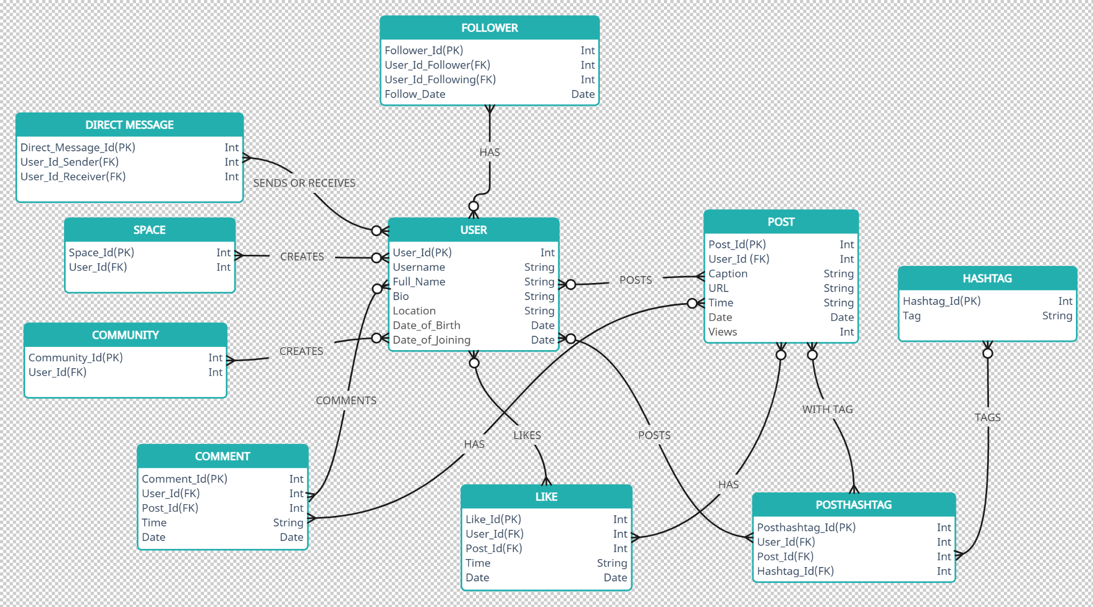

### **Conclusion**

In this project we delved into X’s features and their usefulness in the modern world. Through providing innovative solutions for digital connectivity between people of the world X has revolutionized our lives in more ways than one. From posting text,videos,photos to having live audio conversations and creating communities there is nothing we can’t do on this platform. We also looked at different entities representing its different features, their attributes and relationships between the entities. This provided us to understand X’s data model and visualize the working of the platform. In the end we can only say that X is a pathbreaker in recent human history whose real impact on us can be perfectly understood only in the future.

### **Technical Documentation Link -**

### [**https://docs.google.com/document/d/1ZiqHAftVmx-MNpuZWPNygX5tTOUCesLoIOwGlP3LvCQ/edit?usp=sharing**](https://docs.google.com/document/d/1ZiqHAftVmx-MNpuZWPNygX5tTOUCesLoIOwGlP3LvCQ/edit?usp=sharing)

### 

### **Video Presentation Link -**

[**https://drive.google.com/file/d/1TH0E40_b0QxNqCWQp2UI8j6MVneJDZJy/view?usp=sharing**](https://drive.google.com/file/d/1TH0E40_b0QxNqCWQp2UI8j6MVneJDZJy/view?usp=sharing)